

Instruction Set

An instruction is a command given to the computer to perform a specified operation on a given data.
The instruction set is the collection of instructions which the microprocessor is designed to execute.
The assembly language program comprises of the collection of instructions to perform a certain operation.
Different companies such as Intel, Motorola, etc. have different instruction set.

Type o

Data transfer/ Copy Instruction Arithmetic Instruction
Logical Instruction
Branching Instruction
—-> Machine control Instruction
- Byte Instruction
- Byte Instruction
- Byte Instruction



Data Transfer Instruction
These instructions are used to transfer data from one location to another, i.e. source to destination. It may include:

Register Register (MOV A, B)
Register Memory (MOV M, r and MOV r, M )

Data Register (MVI r, data)

Arithmetic Instruction
These instructions are used to perform arithmetic operations like addition, subtraction, increment, decrement. Example- ADD, SUB, INR, DAD, etc.

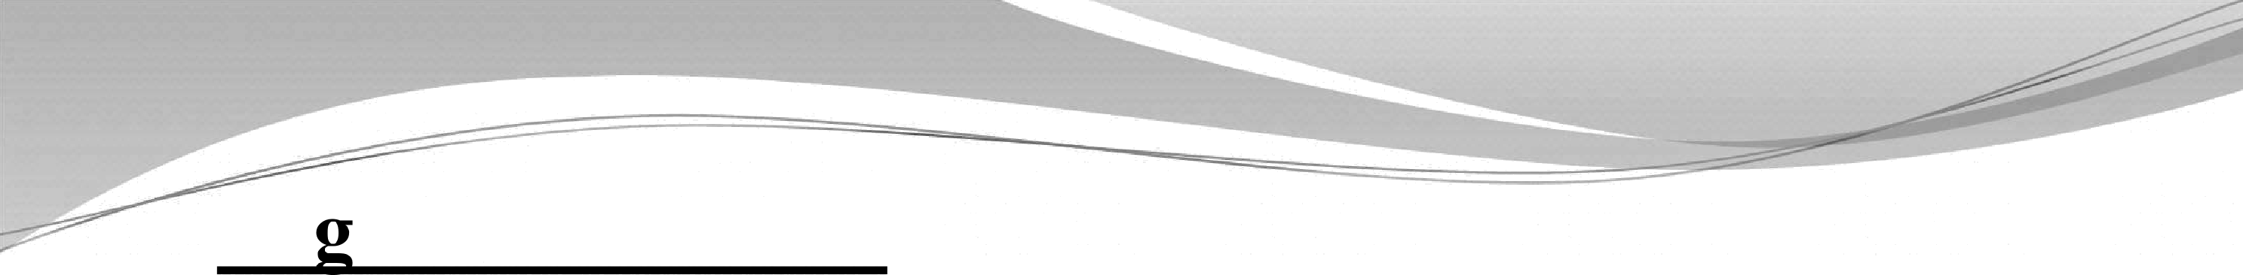

Lo ical Instruction
These instructions performs logical operations such as AND, OR, compare, rotate. Example- ANA, XRA, CMP, ORA, RAL.

Branching Instruction
The instruction under this group performs conditional and unconditional jump, subroutine call and return and restart. Example- JMP, CALL, RST, etc.

I/O and Machine control Instruction
This group of instruction includes instruction for input/output ports, stack and machine control operations. Example- IN, OUT, PUSH, POP, HLT, etc.



DA OR
- There are various techniques of specifying data for an instruction. These can be defined as:
•’ Instruction itself includes 8 bit/16 bit data
•’ Instruction includes address of the memory location, I/O

•^ Instruction has only one register.
•’ Instruction has two register.
•’ In some instruction data is implied.

ADDR OD
- Instruction has opcode and operand. There are different techniques to specify operand in an instruction. These techniques are called as addressing modes.
- Intel 8085 has the following addressing modes:
- Direct addressing mode
- Register addressing mode
- Register indirect addressing mode
- Immediate addressing mode
- Implicit/Implied addressing mode



Direct addressine mode
Address of the operand (data) is given in the instruction itself.
Example-

LDA 6000H | Load the accumulator with the contents of the memory location 6000H
STA 2400H | Store the contents of the accumulator in the memory location 2400H
IN 02 | The data available on the 8 bit address of the input port is moved to the accumulator


Register addressing mode
Operand is one of the GPR or the accumulator.
Opcode specifies the operation to be performed and address of the registers.
Operation takes place between registers. Example-

MOV A, B | Move the content of the register B to register A
ADD B | Add the content of the register B to the content of  the register A

Register Indirect addressing mode
Address of the data is present as the content of the another register pair.
Example

LXI H, 2500H | Load H-L pair with 2500 H
MOVA,M | Move the content of the memory location whose address is in H-L pair to the accumulator
HLT | Halt

LXI H, 2500H | Load H-L pair with 2500 H
ADD M | Add the content of the memory location whose address is in H-L pair to the content of the accumulator
HLT | Halt

Immediate addressing mode
In this addressing mode the operand (data) is specified within the instruction itself.
Example

MVI A,05 | Move the data 05 into the accumulator
ADI 06 | Add 06 to the content of the accumulator
LXI H, 2500 | 2500 is 16 bit data and is loaded into H-L pair

Implicit/ Implied addressing mode
In this type of instruction, operand is the content of the accumulator.
No data, address of data, register are present in the instruction.
Example

CMA | Complement the content of the accumulator
RAL | Rotate accumulator left through carry
RAR | Rotate accumulator right through carry
RLC | Rotate accumulator left


s an
addr | 16-bit address of the memory location
data | 8-bit data
data 16 | 16-bit data
r,r .r2 | One of the register A, B, C, D, E, H, L
A, B, C, D, H, L | 8-bit register
A | Accumulator
M | Memory whose address is in H-L pair
H | Appearing at the end of a group of digits specifies hexadecimal
 | Represents one of the register pair B represents B-C pair  D represents D-E pair  H represents H-L pair
[] | The content of the register identified within the brackets
[[]] | The content of the memory location whose address is in the  register pair identified within the brackets


a Transfer

Instruction | Operation | Machine  cycles
MOV A, B | Move the content of register B to register A | 1
MOV r, M | Move the content of memory to register. | 2
MOV M, r | Move the content of the register to the memory location addressed by H-L pair. | 2
MVI r, data | Move immediate data to the register | 2
MVI M, data | Move the immediate data to memory location addresses by H-L pair | 3
LXI rp, data 16 | Load the register pair with the 16 bit data | 3
LDA addr | Load the accumulator with the content of the specified address in the instruction | 4

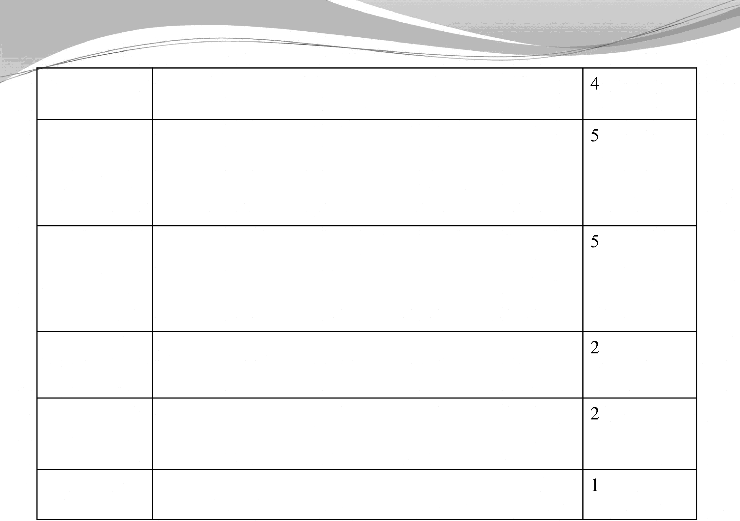STA addr

LHLD addr

SHLD addr

LDAX rp

STAX rp

XCHG
Store the content of the accumulator in the specified memory location
Load the content of the specified memory location in the address to the L register and the content of the next memory location is loaded into H.

Store the content of the L register in the specified address in the instruction and the content of the H register is stored in the next memory location.

Load the accumulator with the content of the address stored in the rp

Store the content of the accumulator in the memory location whose address is in the register pair rp.

Exchange the contents of H-L pair with D-E pair.


iit
metic Group

ADD rI, | Add register to accumulator. [A]<-[A]+[r] | 1
ADD M | Add the content of the memory to accumulator [A]•=- [A]+[[H-L]] | 2
ADI data | Add immediate data to'itecumulator [A]•=- [A]+data | 2
ADC r | The content of register r and carry status are added with the content of the accumulator | 1
DAD rp | Add the content of register pair rp to the content of  H-L pair [H-L]•=- [H-L]+[rp] | 3
SUB r | Subtract register from memory [A]<=— [A]-[r] | 1
SUB M | Subtract memory from accumulator [A]+- [A]-[[H-L]] | 2
SUI data | Subtract immediate data from accumulator  [A]•=- [A]-data | 2

INR r
e content of register r an
from the content of the accumulator.
Content of register r are incremented by one [r]•=-[r]+1

INR M Increment the content of memory location in H-L pair
by one [[H-L]]•=- [[H-L]]+1

DCR r Decrement the content of register by one
] [ -1
DCR M Decrement the content of memory location in H-L pair
by one [[H-L]]<=- [[H-L]]-1

INX rp DCX rp
Increment the content of register pair rp by one
[rp] •=- [rp]+1
Decrement the content of register pair rp by one

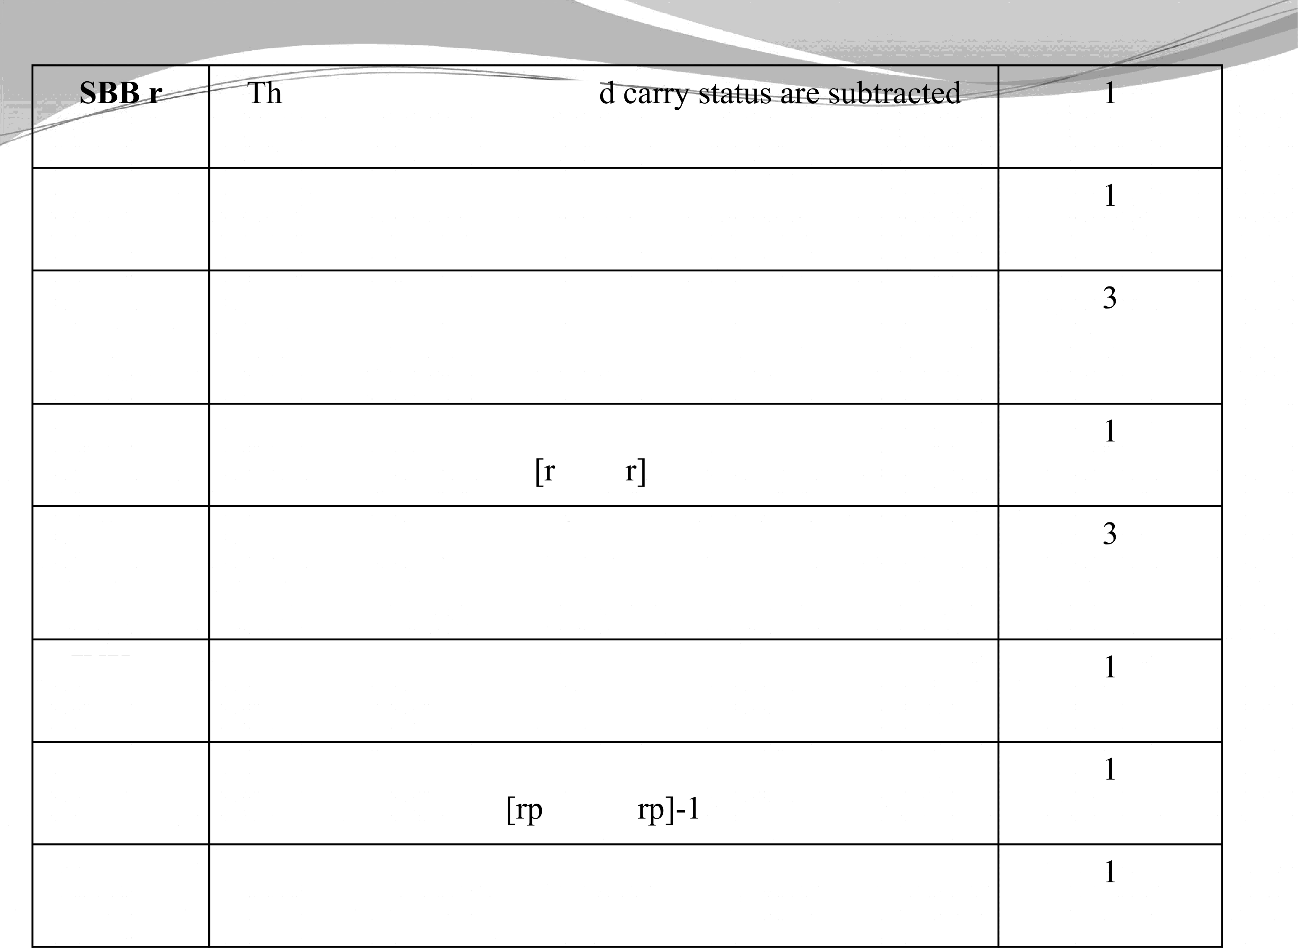DAA Converts the content of accumulator from Hexadecimal to
Decimal



Logical Group

ANA r | The content of register r is ANDed with the content of accumulator | 1
ANA M | The content of the memory location addressed by H-L pair is ANDed with content of accumulator | 2
ANI data | The data is ANDed with the content of the accumulator | 2
ORA r | The content of the register is ORed with the content of the accumulator | 1
ORA M | The content of the memory location addressed by H-L pair is ORed with content of accumulator | 2
ORA data | The data is ORed with the content of the accumulator | 2
XRA r | The content of the register r is EXCLUSIVE-ORed with the content of the accumulator | 1



XRI data | The data is EXCLUSIVE-ORed with the content of the accumulator | 2
CMA | Complement the content of the accumulator | 1
CMP r | The content of the register r is subtracted with the content of the | 1
 | accumulator and the status flag are set according to the result
CMP M | The content of the memory location addressed by H-L pair is | 2
 | subtracted with the content of the accumulator and the status flag
 | are set according to the result. The result of the accumulator
 | remains unchanged.
IT£C | The content of the accumulator is rotated left by one bit without | 1
 | carry“
ITRC | The content of the accumulator is rotated right by one bit without | 1
 | carry
RAL | The content of the accumulator is rotated left by one bit with | 1
 | carry
RAR | The content of the accumulator is rotated right by one bit with  carry | 1


Branc
- The instruction in this group change the normal sequence of the program.

Branch Group

Conditional

- Unconditional- The program is transferred to a specified memory location unconditionally.

Unconditional
- Conditional- The program is transferred to a specified memory location when certain condition is satisfied.



Unconditional instructions
JMP addr- Program jump to the instruction specified by

the address (label) unconditionally.
Conditional instructions

JZ addr  JNZ addr | Jump if the result is zero  Jump if the result is non-zero
$C addr  JNC addr | Jump if there is a carry  Jump if there is no carry
JP addr  JM addr | Jump if the result is plus  Jump if the result is minus
JPE addr  JPO addr | Jump if even parity  Jump if odd parity



Machine control Group

IN port-address | The data available on the port is moved to the accumulator | 03
OUT port-address | The content of the accumulator is moved to the port specified by its address | 03
HLT | The program execution is stopped | 01



Problems

WAP to place the content of the memory location FC50H in register B and that of FC51 in register C. The content of FC50 and FC51 are llH and 12H.
WAP to place 05 in the accumulator. Increment it by one and store the result in the memory location FC50H.
WAP to add two numbers 49H and 56H which are stored in memory location 2501H and 2502H and store the result in 2503H.

WAP to subtract two numbers 48 and 32 which are stored in 2501H and 2502H and store the result in 2503H.


WAP to find one’s complement of 96H which is stored in 2501H and store the result in 2502H.
WAP to find the one’s complement of 5485H. The number is stored in memory location 2501H, 2502H and the result is to be stored in memory location 2503H and 2504H.
WAP to find two’s complement of 96H which is stored in
2501H and store the result in 2502H.
WAP to find the two’s complement of 5B8CH. The number is stored in memory location 2501H, 2502H and the result is to be stored in memory location 2503H and 2504H.
WAP to find smaller of two numbers 56H and 32H. The first number is stored in 2501H and second number is stored in 2502H. The result is to be stored in 2503H.

WAP to access data 33H and CCH from 01H and 08H. Do the OR operation and transfer the resultant value to port address 03H.
WAP to access data 32H and 45H from 2501H and 2502H, add them and rotate the result right 3 times and store the result in memory location 2503H.
WAP to access data 33H and CCH from 2501H and 2502H. Do the AND operation and store the result in memory location 2503H.

- WAP to find product of two 8 bit numbers and the numbers are 84H and 56H.
Start

Get Multiplicand and Multiplier
Initial value of Product=00, Count=08
Shift Product Left one bit Shiñ Multiplier Left one bit

No IS
Carry from Multiplier ?

Product = Product + Multiplicand
Count = Count-1

No IS
Count = 0?

Store Product

Stop



Microprocessor Programming

Program contains a sequence of instructions.
Software contains a set of programs written for a particular computer.
A computer understands information composed of zeros and ones.
Machine language program contains instruction in the form of zero and ones.

10000000 | Add content of registers A and B
01111000 | Move content of register B to register A
01110110 | Stop

Demerits of machine language program
.-i Difficult to understand or debug a program
O Entry of a program is slow and programs are long O Program writing is difficult and tiresome
O Chances of errors in writing the program
  - To facilitate programmer machine codes are written in hexadecimal system. The mistakes can easily be detected.

Hexadecimal language ->
Microprogram

  - Source language a program.

Machine language
- Language in which programmer writes

  - Object/Machine language — Language in which a computer works.



Assembly language program
  - It is one of the easily understandable language.
  - Program is wriHen in alphanumeric symbols instead of zeros and ones.
  - Meaningful symbols are chosen for the purpose, ex- ADD, SUB, ORA, CMA.

Such symbols are called mnemonics.
  - Programs written in assembly language is easier and faster than machine language.

iFw-level language- A microprocessor specific language is known as a low level language.

Low-level language
Machine language


Assembly language

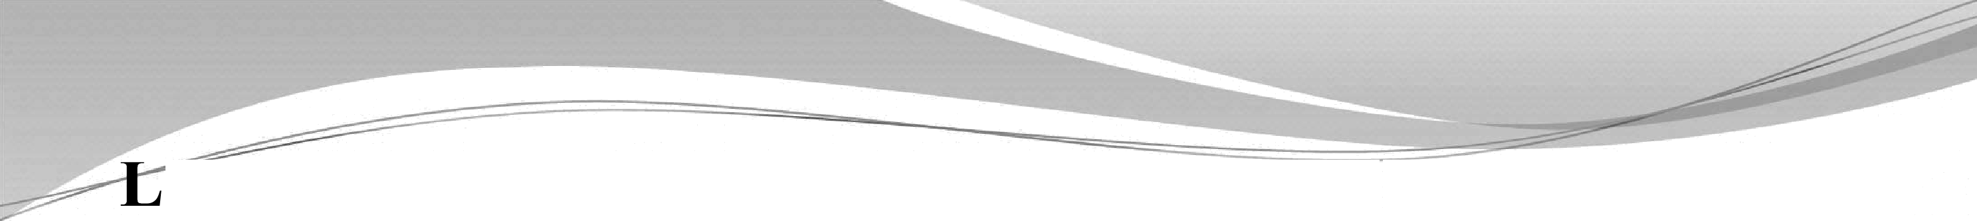

Assembler- A program which translates an assembly language program into a machine language program is called an assembler.

Self-assembler- It is an assembler which runs on the microcomputer for which it produces object codes.

Cross-assembler- It is an assembler that runs on a computer other than that for which it produces object codes.


Disassembler- Its role is complementary to that of an assembler and converts a machine language program to an assembly language program.
Hand assembly- In an ordinary kit assembler is not available. Programmer writes program in assembly language and converts it into the hexadecimal codes.
One-Pass assembler- An assembler which goes through an assembly language program only once.
Two-Pass assembler- An assembler which goes through an assembly language program twice is called a two-pass assembler.
First pass- It collects all the labels
Second pass- It produces machine codes for all instructions and assign addresses.

Advantages | Disadvantages
The computation time of assembly language is less. | 1. Programming is difficult and time consuming
The computation time of assembly language is less. | 2. Program is computer oriented
The computation time of assembly language is less. | 3. Program is not portable
The computation time of assembly language is less. | 4. Program is long

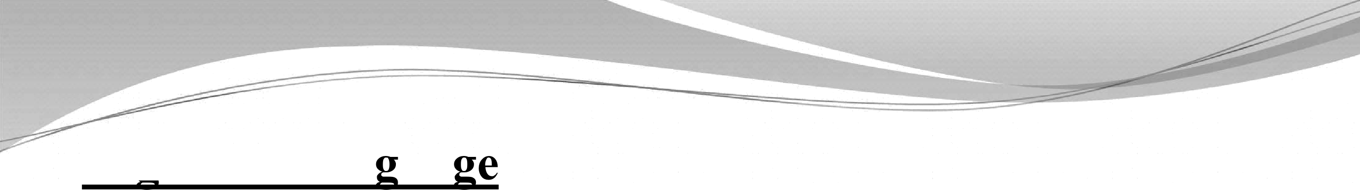

Hich level lan ua
Instructions in high level language are called statements.
Statements more precisely resembles English and Mathematics than mnemonics.
This language is procedure oriented than computer oriented. The programs are portable.
One statement of high level language corresponds to many instructions of assembly language.
Examples are FORTRAN, COBOL, BASIC, JAVA, C, etc.
A compiler is needed to translate high-level language to machine codes.



COMPILER
It translates a high-level language program into a machine language.
It is more powerful than assembler.
It occupies more memory space and longer time to produce results.
Self compiler- Compiler runs on the computer for which it produces object codes.
Cross compiler- Compiler runs on the computer other than that for which it produces object codes.



INTERPRETER
It translates a high-level language into object codes, statementwise.
It took one statement at a time, translates it and executes it. It is slower than a compiler.
It occupies less memory space, it is cheaper and suitable for a smaller system.



FORTRAN
FORTRAN stands for Formula Translation.
It is the first high level language developed in 1950s by
IBM.
It is an ideal and most popular language for scientific and engineering computation.
Initially FORTRAN IV was popular.
In 1977 the American National Standard Institute (ANSI) published a standard for FORTRAN.
The standard form of language is FORTRAN 77, FORTRAN 90, FORTRAN 95.



BASIC
It stands for Beginners All-purpose Symbolic Instruction Code. It is simple and easy language and was introduced in 1965.
It is suitable for scientific and engineering applications and is
not as powerful as FORTRAN.
QBASIC is a recent version of BASIC and was developed by Microsoft. It uses GUI (Graphical User Interface) and Interpreter.
VISUAL BASIC combine small programs written in BASIC language. It is a powerful tool for developing windows applications (GUI).

C language
It was developed at AT and T’s Bell laboratories in 1972 by Dennis Ritchie.
Programs are small and concise.
It supports library functions which are equivalent to subroutines.
C was first used to write UNIX operating system.
It is used to write system and commercial software packages such as operating system, compilers, spreadsheet, etc.
C++ is an extension of C language. It was developed in 1980 at Bell laboratories. It is an object oriented language.

JAVA
It is an object-oriented programming language derived from C++ and is developed by Sun Microsystems.
Applications written in JAVA are capable of running on any platform.
It is suitable for Internet, desktop, computers, servers, microcontrollers, etc.
Java Script is a scripting language based on JAVA.
Java chips are dedicated microprocessor optimized to run Java based business and embedded applications.

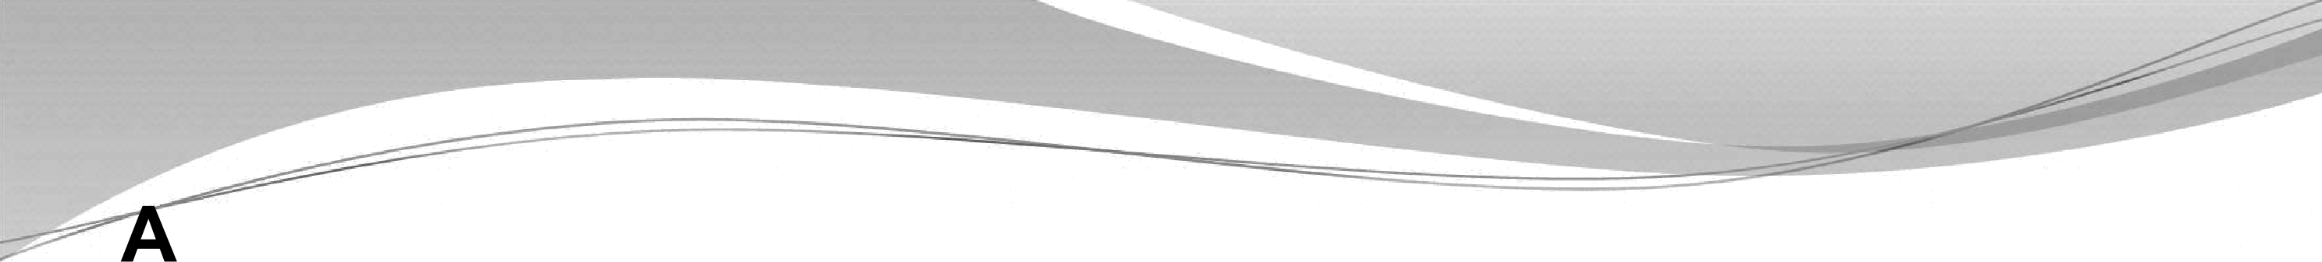

dvantages & Disadvantages of High Level Language

Advantages | Disadvantages
1. Instructions are clear | 1. One has to learn special rules for writing a program in high level language
2. Writing a program is easier and faster | 2. The computation time is more
3. Program is portable | 3. Low efficiency of memory utilization
4. Easier documentation | 4. Extensive hardware and software support is required (Cost of peripherals is high).
5. Problem oriented rather than computer oriented. | 5. A compiler is required which is costly.
6. Standard syntax | 5. A compiler is required which is costly.



lication areas of various lan ua es

Machine language | Assembly language | High level language
1. Small and simple programs | 1. Small to moderate size programs | 1. For large programs
2. Simple control applications where less computation is required | 2. Real-time control applications | 2. Large volume of data is to be processed
3. Applications where prototype is the final product. | 3. Small volume of data to be processed | 3. Large computations are required
3. Applications where prototype is the final product. | 4. Cost of memory is a consideration | 4. Applications having large  memories
3. Applications where prototype is the final product. | 5. In training kits and industrial applications. | 5. Complex mathematical computations
3. Applications where prototype is the final product. | 5. In training kits and industrial applications. | 6. Applications where high cost is justified

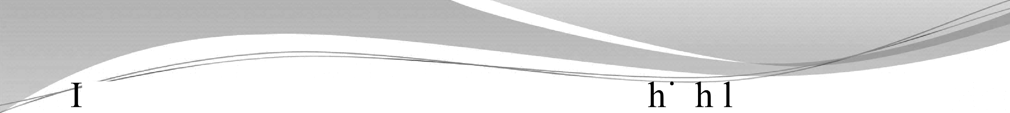

n microcomputer future trends favor's ig evel language due to following reasons:
Hardware and memory becoming less expensive. Large size of memory chips are available at low cost. Compilers are easily available
Efficient high level language are developed



TACK

Stack is a set of memory locations in the memory specified by a programmer in a main program.
These memory locations are used to store the content temporarily during the execution of the program.

The beginning of the stack is defined using:

LXI SP, + + + + .... + +- •- - - 16 bit address
Once the stack location is defined, storing of data bytes begins at the memory address that is one less than the address in the stack pointer register.
PUSH instruction is used to store the content of register pair on the stack

POP instruction is used to transfer the contents from the stack to respective registers.
The stack pointer register tracks the storage and retrieval of the information.
The contents of the program counter can be stored when a subroutine is called.

Instructions

PUSH Rp | Copy the content of the specified register pair on the stack.  Rp can be B, D, H which represents the register pair BC, DE, HL.
PUSH PSW | Copy the contents of accumulator and flags on the stack
POP Rp | Copy the content of the memory locations of the stack into the  specified register pair.
POPPS | Copy the content of memory location into the registers

The stack space grows upward in the numerically decreasing order of memory addresses.
The storage and retrieval of data bytes on the stacks should follow the LIFO sequence.
Information in stack locations is not destroyed until new information is stored in those locations.



Example 1
The stack pointer has to be initialized at 2099H and the content of the register pair HL (42F2H) are stored on the stack and after certain delay the content of the HL pair are retrieved from the memory location.

Memory

Location
2000
2003
2006
2007

200F
2010

Mnemonics

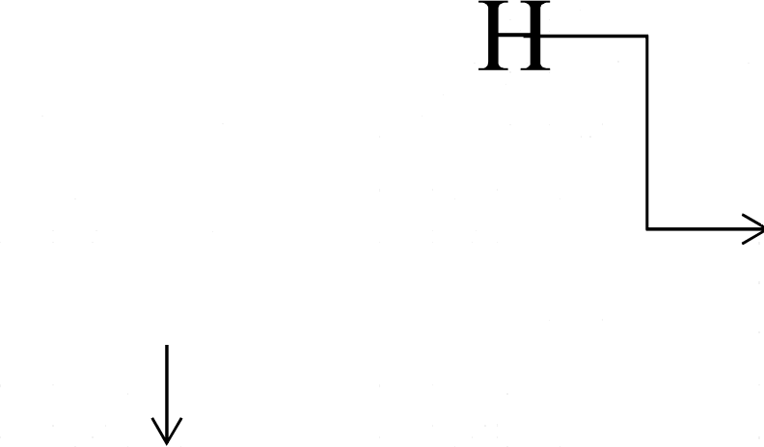LXI SP, 2099H
LXI H, 42F2
PUSHH
Delay, Counter

POP H

Register Content

A |  |  | 
B |  |  | 
D
H | 42 | F2 | L
SP 2099

8085 Register
A |  |  | F
B |  |  | C
D |  |  | E
H | 42 | F2 | L
SP | 2097

2097 SP
Memory
F2
42
X

2098
2099 SP

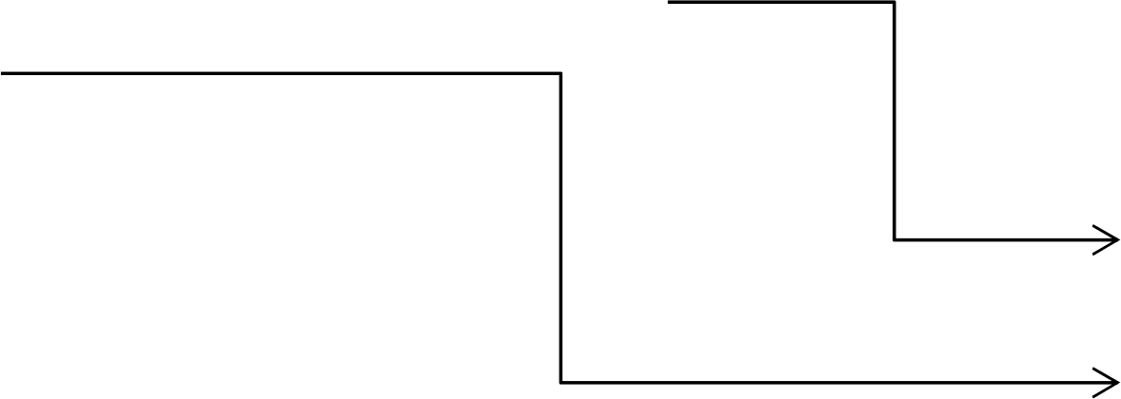

Content on the stack and in the Registers After the PUSH Instruction

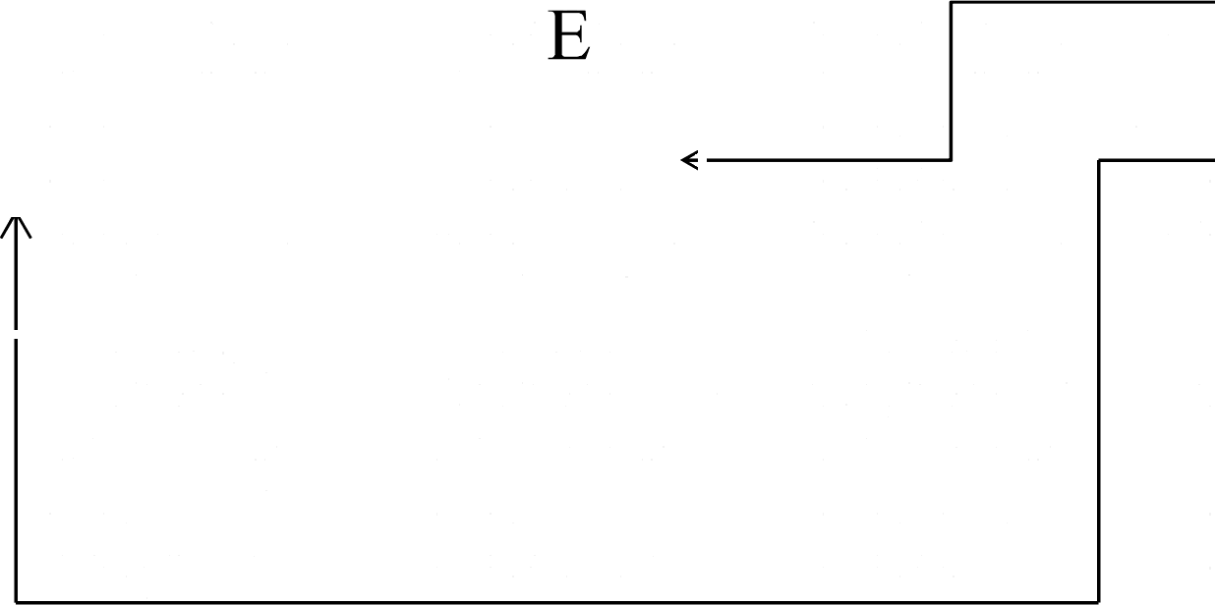
8085 Register
Memory
F2
42
X

A |  |  | F
B |  |  | 
D
H | 42 | F2 | L
SP | 2099

Content on the stack and in the Registers After the POP Instruction

2097 SP
2098
2099

Example 2
The stack pointer has to be initialized at 2489H and the content of the register pair HL (2150H), BC (2280H), PSW are stored on the stack and after certain delay the content of the HL, BC, PSW are retrieved from the memory location.

WAP to add two 16 bit numbers 5B98H and 8E4CH which are stored at 2501H to 2504H. Store the results in the memory locations 2505H to 2507H.
WAP to divide two 8 bit numbers.



SUBROUTINE

Certain programs have operations that occur several times but they are not available as individual instructions.

Example-Multiplication, Square-root, etc.
A subroutine is a group of instructions written separately from the main program to perform a function that occurs repeatedly in the main program.
It avoids repetition of the smaller programs. Subroutine is implemented using:
Call - Call a subroutine
RET - Return to main program from a subroutine

Subroutine is called
CALL

At the end of the
Subroutine
RET

Main Program
Content of the Program Counter is stored on the stack

Content of the Program Counter is retrieved from the stack
Subroutine
RETURN

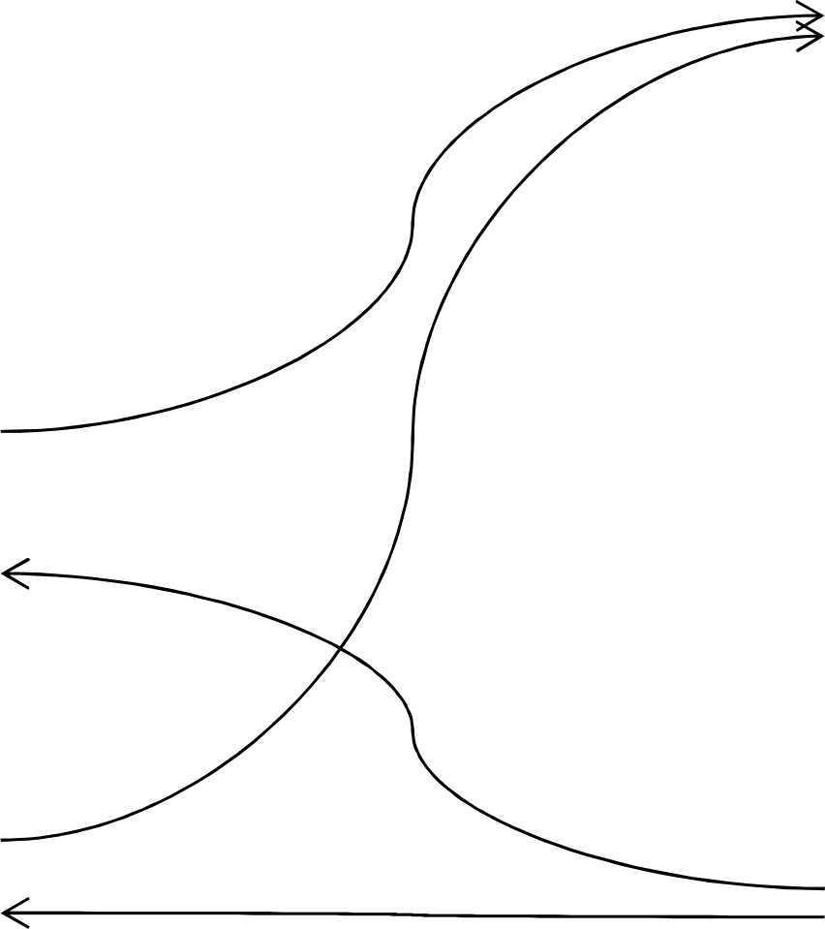
Call Subroutine
Call Subroutine



Conditional Call Instructions
The program is transferred to the subroutine if the condition is met otherwise the main program is continued.

CC | Call subroutine if Carry flag is set
CNC | Call subroutine if Carry flag is reset
CZ | Call subroutine if Zero flag is set
CNZ | Call subroutine if Zero flag is reset
CM | Call subroutine if Sign flag is set
CP | Call subroutine if Sign flag is reset
CPE | Call subroutine if Parity flag is set
CPO | Call subroutine if Parity flag is reset

Conditional RETURN Instructions
The sequence returns to the main program if the condition is met, otherwise the sequence in the subroutine is continued.

RC | Return from subroutine if Carry status is set
RNC | Return from subroutine if Carry status is reset
RZ | Return from subroutine if Zero status is set
RNZ | Return from subroutine if Zero status is reset
RM | Return from subroutine if Sign status is set
RP | Return from subroutine if Sign status is reset
RPE | Return from subroutine if Parity status is set
RPO | Return from subroutine if Parity status is reset

Restart (RST) Instruction
It is a one byte CALL instruction which transfers the
program execution to a specific location.
It is generally used in conjunction with the intemipt process.

RST 0 | Call OOOOH
RST 1 | Call 0008H
RST 2 | Call 0010H
RST 3 | Call 0018H
RST 4 | Call 0020H
RST 5 | Call 0028H
RST 6 | Call 0030H
RST 7 | Call 0038H

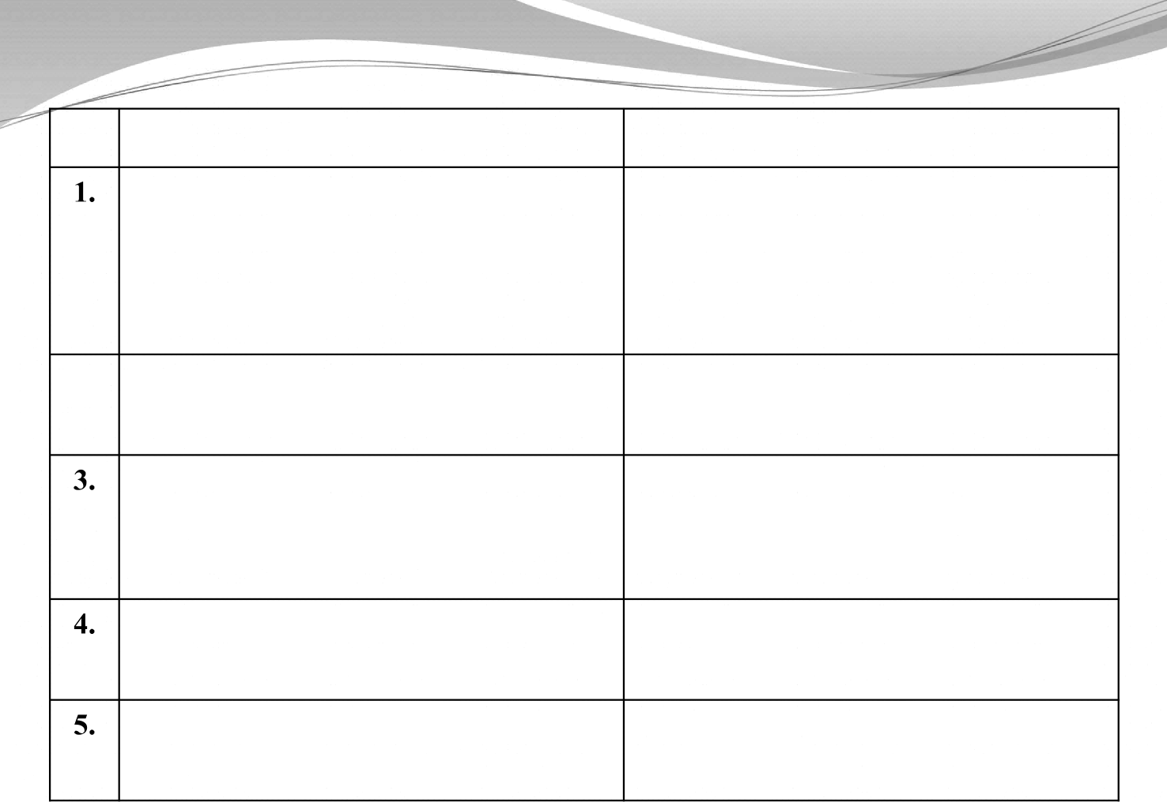
CALL and RET
When CALL is executed, the microprocessor automatically stores the 16 bit address of the instruction next to CALL on the stack

2. When CALL is executed, the stack pointer register is decremented by two

The RET instruction transfers the contents of the top two locations of the stack to the program counter

When the instruction RET is executed, the stack pointer is incremented by two
There are eight conditional CALL and RETURN instruction
PUSH and POP
The programmer uses the instruction PUSH to save the contents of the register pair on the stack

When PUSH is executed, the stack pointer register is decremented by two

The instruction POP transfer the contents of the top two locations of the stack to the specified register pair

When the instruction POP is executed the stack pointer is incremented by two
There are no conditional PUSH and POP instruction



Timing diagram
It is a graphical representation of necessary steps which are carried out in a machine cycle.
Pictorial representation of execution of an instruction with the help of various control/timing and status signals.
Based on different sets of operations carried out in 8085 microprocessor, there are different timing diagram:
Opcode fetch Memory read Memory write I/O read
I/O write



Timing diagram for Opcode Fetch Cycle

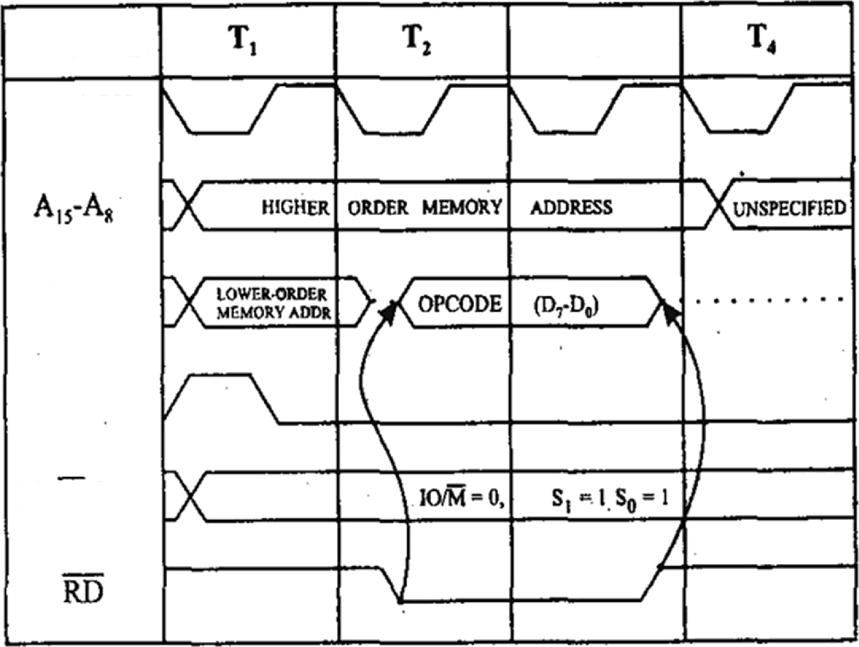
SIGNAL
CLOCK
T,
'7‘
D,
ALE
IOX,S,,S,

Sequence of steps for opcode fetch operation
First clock cycle (T₁)- Microprocessor sends the address of the memory where the opcode is available.
Second clock cycle (T₂) — The control unit sends the control signal RD to the memory chip to enable the read operation. The byte is placed from the memory location on the data bus.
Third clock cycle (T₃) — The opcode is placed in the IR. Fourth clock cycle (T₄)- The opcode is decoded.



Timing diagram for MVI A, Data
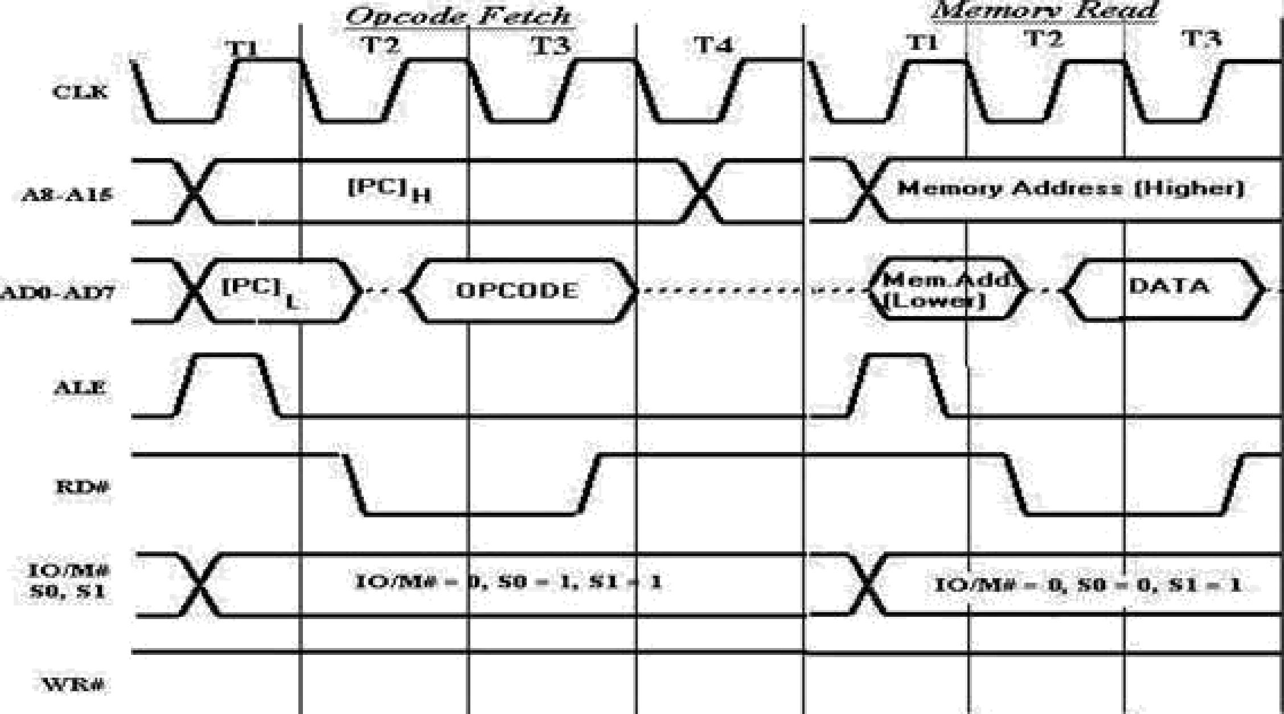

Sequence of steps for memorv read operation
First clock cycle (T₁)- Microprocessor sends the address of the memory where the data is available.
Second clock cycle (T₂) — The control unit sends the control signal RD to the memory chip to enable the read operation. The byte is placed from the memory location on the data bus.
Third clock cycle (T₃) — The data enters the CPU.

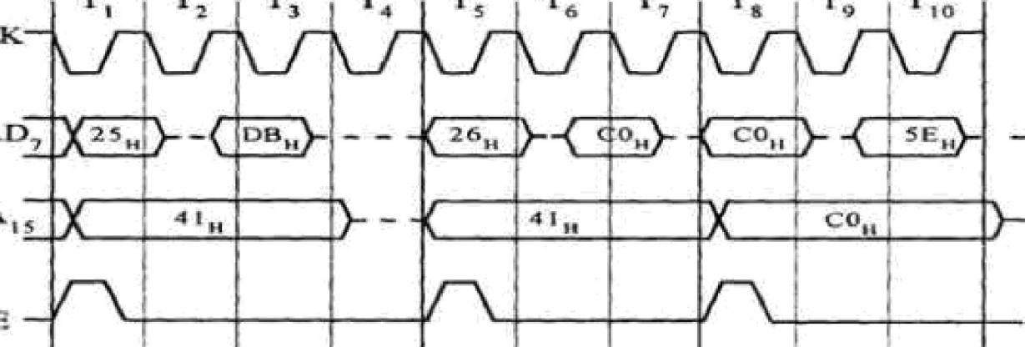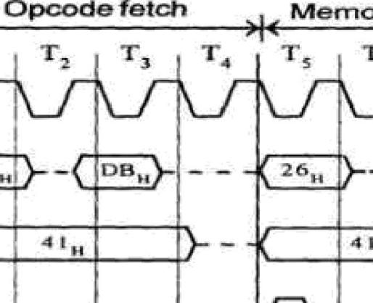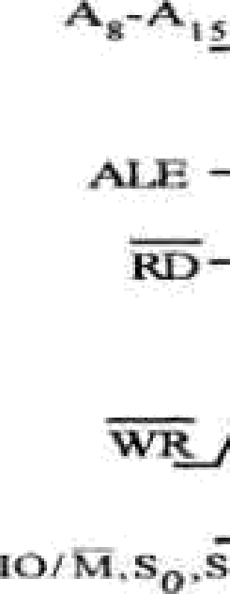
iagra
IO read o eration
Eg:









Timing diagram for memory write Operation

h'šcmon° &fiN ñsnvbżae Cs"r@3T)

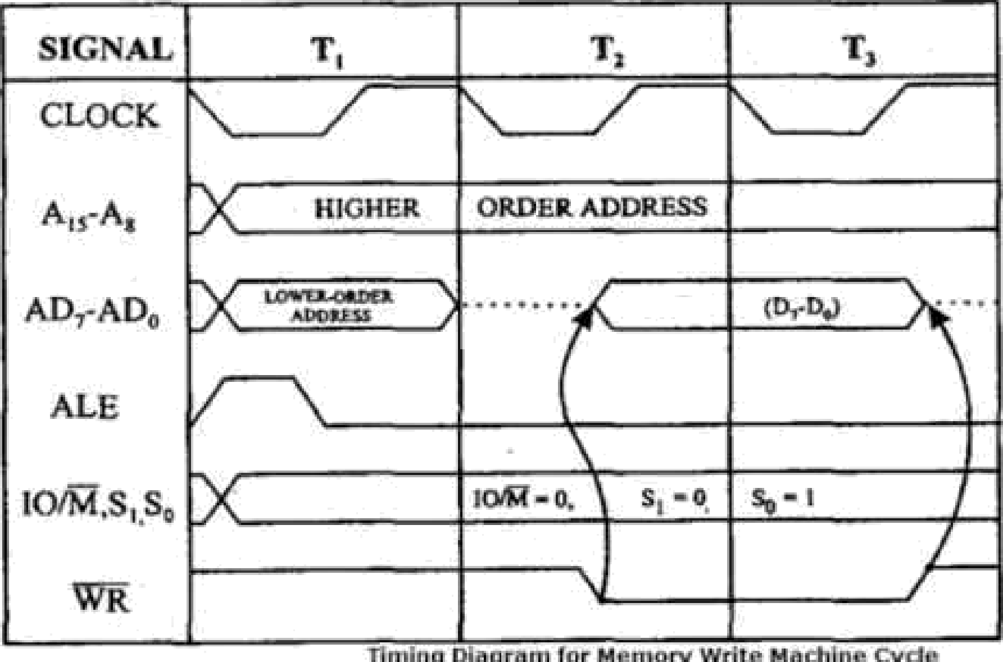

Sequence of steps for memorv write operation
First clock cycle (T₁)- Microprocessor sends the address of the memory where the data is to be stored.
Second clock cycle (T₂) — The control unit sends the control signal WR to the memory chip to enable the write operation.
Third clock cycle (T₃) — The byte is placed from the microprocessor on the data bus and stored in memory.

